**Steps for deploy three tier Application:**

1. Ubuntu user provide 777 permission

Change ownership command “sudo chown -R web:web Folder_name”

### Command

sudo chmod -R 777 /var/www/html

* sudo – admin access
* chmod – command for permissions
* -R – recursively for all subfolders
* 777 – Read and write all permissions, and variables based on the need
* /var/www – path

We can view the permissions using ls -l inside a folder to see the permissions.

akash:/$ sudo chmod -R 777 /var/www   
akash:/$ ls -l

1. Installed MySQL DATABASE
2. Login MYSQL from “root” simply run command “MYSQL” after login
3. Create user and grant privileges after that create database
4. Import SQL files into DATABASE > go to SQL file location and type command for import.

### Import SQL

mysql -u username -p database_name < /path/to/your/file.sql

### Export SQL

mysql -u username -p database_name > /path/to/your/file.sql

1. Steps for backend run:

Pull GitHub backend files in a directory

Installed Node version Manager (NVM)

Install npm

**Using Node Version Manager (nvm)**

If you have nvm installed, this is the easiest way:

1. **Install nvm** (if you haven't already):

curl -o- https://raw.githubusercontent.com/nvm-sh/nvm/v0.39.5/install.sh | bash

Then, restart your terminal or run:

source ~/.nvm/nvm.sh

1. **Install Node.js version 16.20**:

nvm install 16.20

1. **Set it as the default version** (optional):

nvm alias default 16.20

### PM2 install (background processor manager)

npm install pm2 -g

### Verifying the Installation

After installation, verify the installed version:

node –v

npm -v

1. Edit “.env” and take path of database

“mysql://database_username:password@IP/localhost:3306/Database_name

1. Go to package.json location and type

“npm install” after that, make a folder node_module

1. Run command “node src/index.js”

Output : { Product: Product }

Server is listening on 3000

Executing (default): SELECT 1+1 AS result

Database connected!

1. Start process command “pm2 start “index.js” and before run open ports from NSG 3000 and 3306

“if localhost:3000 connect is failed the type a command ‘**apt install curl’** ”

Fronted!

1. Install nginx
2. Make dir and git clone “project”
3. Npm install “don’t remove package-lock.json” with Angular installed (sudo npm install -g @angular/cli)
4. Npm run build “after that auto make DIST folder copy all content in DIST folder and paste into /var/www/html” and restart Ngnix
5. Firewall active

“sudo apt install ufw”

“sudo ufw enable”

“ufw allow http” (https ,ssh and port number which you want to open in firewall)

“ufw status”

1. Purchase domain
2. Add IP in Domain (Record A)
3. Reverse Proxy and SSL certification Install (wildcard certificate for multiple subdomain)

sudo snap install --classic certbot

sudo certbot certonly --manual -d *.abuzar.in.net

after Download SSL certificates the path will be /etc/letsencrypt/live/Domain_name/fullchain.pem

/etc/letsencrypt/live/Domain_name/privkey.pem

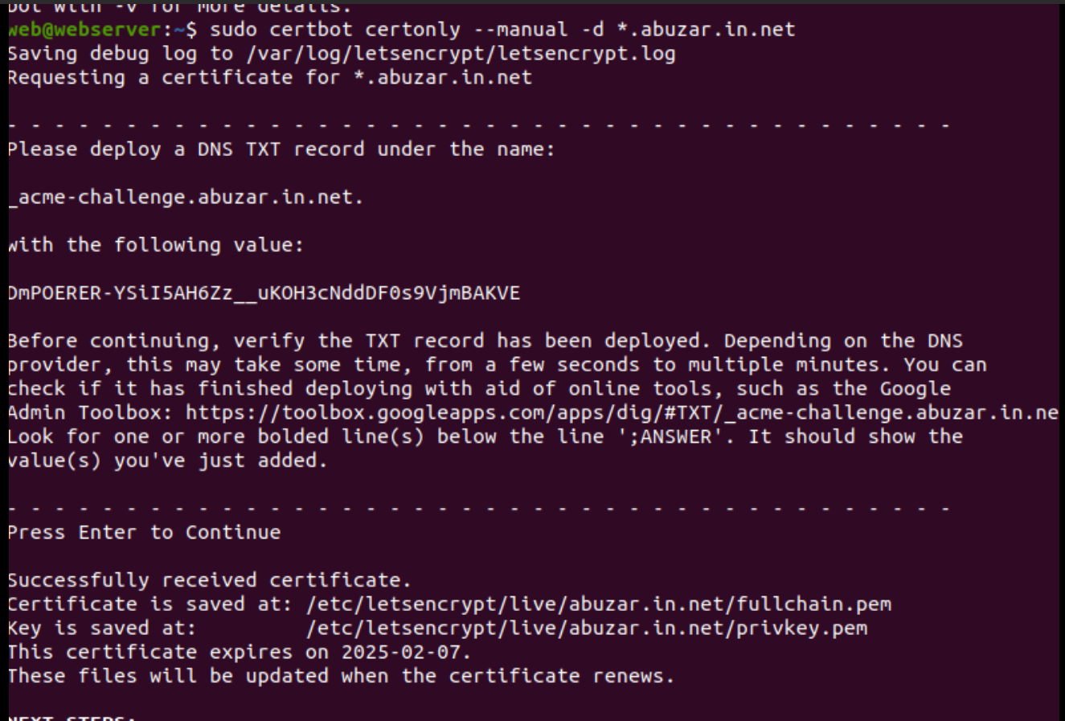

9) DNS TXT add

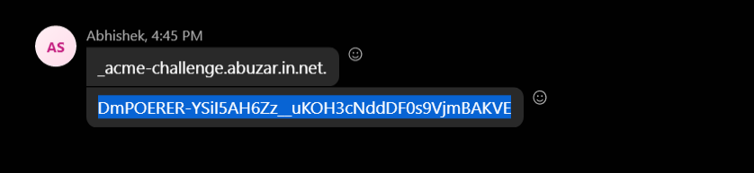

SSL certification converter link (Azure web app support SSL certificate.PFX)

https://www.sslshopper.com/ssl-converter.html

